* **[How to sync files on a Mac](https://sharepoint.rackspace.com/Learning/Articles/Pages/SharePoint-2013--how-to-sync-files-on-a-mac.aspx)**

This one is for all the Mac users out there; if you haven’t figured out how to do this you’re in for a treat.  I’m not going to lie to you, not being an experienced Mac user made this much more difficult than it probably should have been. Anyways, if you’re using a Mac syncing with your SharePoint site through OneDrive isn’t really an option as this functionality isn’t available. However, there is a way to sync your SharePoint site with your Mac without using OneDrive which will allow you to upload, edit, and save all your changes without ever having to login to SharePoint.

1. On your Mac, in the upper right-hand corner click the **Spotlight**.

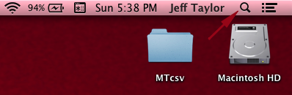

2. Type **Microsoft Document Connection** and click **Microsoft Document Connection**.

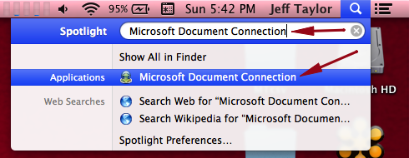

3. Microsoft Document Connection application will open, click **Add Location**.

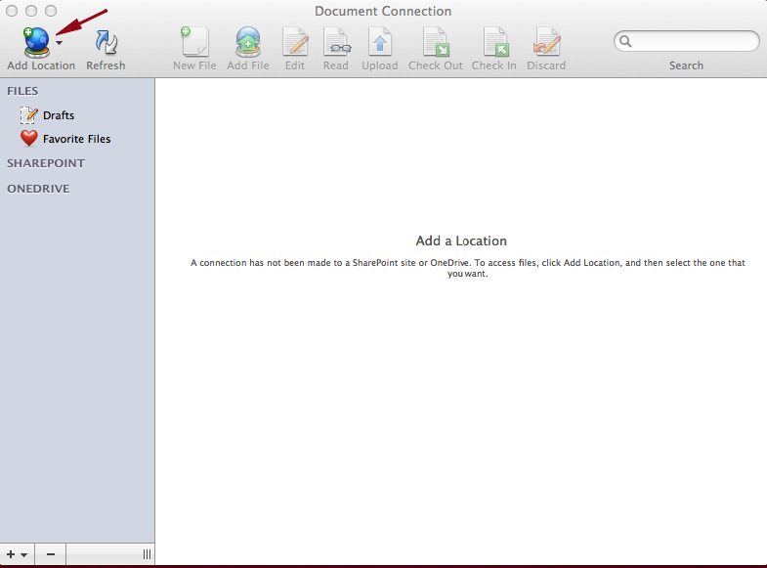

4. From the drop-down click **Connect to a SharePoint Site…**

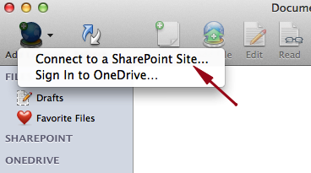

5. In the Address: field type your SharePoint site URL, in this example I will type my root site [**https://scuba3.atrackspace.com**](https://scuba3.atrackspace.com/).

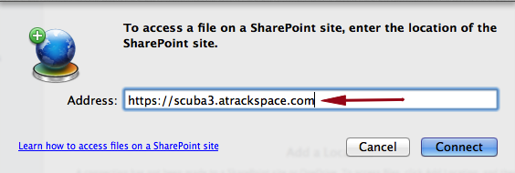

6. Click **Connect**.

https://sharepoint.rackspace.com/Learning/PublishingImages/How%20to%20sync%20files%20on%20a%20Mac/maconedrive6.png

7. When asked to authenticate, type your SharePoint username and password.

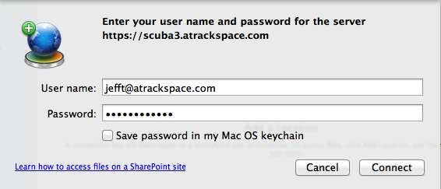

8. Click **Connect**.

9. After a few moments, your SharePoint site will be connected. On the left hand-side of the screen under SharePoint you will see your SharePoint URL you entered.

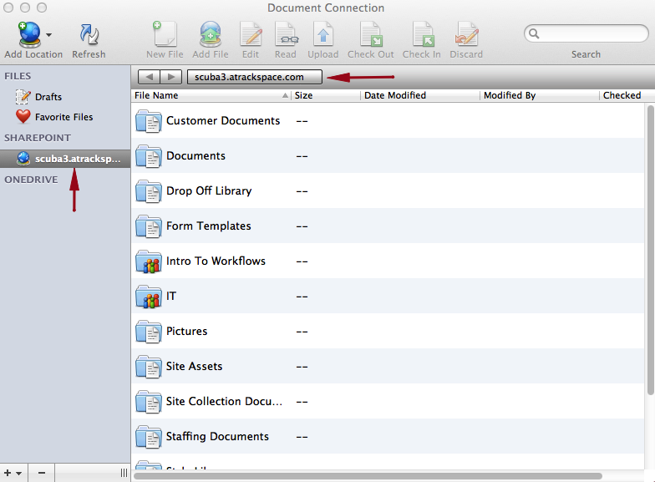

That’s it! Test it out, if you update any document from your SharePoint site on your Mac it will be updated once saved.